Scoring Summary Table
Scale/index/  composite | Raw score | T score | %ile | 90% CI
Inhibit
Self-Monitor
BRI
Shift
Emotional Control
ERI
Initiate
Working Memory
Plan/Organise
Task-Monitor
Organisation
of Materials
CRI
GEC

T scores between between 60-64 are considered ‘mildly elevated,’ 65-69 ‘potentially clinically elevated’, at or above 70 ‘clinically elevated’.
Percentile scores indicate the percentage of children in the standardisation sample with scores at or below that same value.
ADHD-C = attention deficit/hyperactivity disorder, combined type; ADHD-I = attention deficit/hyperactivity disorder, inattentive type; TD = typically developing
Normed for gender and age group
Page 257 – elevation base rates
259 –classification for adhd and asd
263 – Reliable change scores

T-scores between 60 and 64 represent scores between 1 and 1.5 STD above the mean = mildly elevated and may warrant interpretation
65 and 69 = 1.5 and 2 standard deviations above means = indicates scores potentially clinically elevated.
T scores between 60 and 64 are considered mildly elevated
Scores between 65 and 69 are potentially clinically elevated
Scores above 70 are considered clinically significant
50 is average.
Base rates: frequency with which scores are seen in the standardisation and clinical samples

Base rates for normative sample

Distribution
While t score of 50 is associated with percentile of 50 in normal distribution, the focus on problematic behaviours results in a positively skewed distribution with most scores in the standardisation sample clustering at the lower end of the distribution and much smaller number of scores forming a tail on the higher end of the distribution

How many standard deviations more problematic than the mean girls of similar age and is as high as that shown by ---% of other girls that age.

Inhibit
- Inhibit T-score of 67 is 1 standard deviation more problematic than the mean for 11-13-year-old girls and is as high as 95% of other girls that age.
- A score like hers is seen in only 10% of typically developing children
- Scores above or equal-to 65 on the self-form are seen in 27% of students with ADHD-C and 23% of students with ADHD-I., but also in 18% of children with ASD.
GEC
Inhibition of impulsive responses underlies, or enables the cognitive aspects of executive function and that the ability to remain flexible and emotionally well-modulated are essential to initiating tasks, sustaining WM; and planning, organising, and monitoring problem-solving approaches.
One needs to be appropriately inhibited, flexible and under emotional control for efficient, systematic, and organised problem-solving to take place
To do
- First review scores on the inhibit, self monitor shift and emotional control scales. For elevations.
- If BRI or ERI is significantly elevated, it is likely that poor behaviour regulation or emotion regulation is negatively affecting active cognitive problem solving domains.
- Priority of treatment effort to focus emphasis on interventions aimed at inhibition, flexibility, or emotional control.
- It is important to note that elevation in the above does not negate the meaningfulness of elevated CRI scales, it means that problems with cognitive regulation need to be considered simultaneously.

Reference
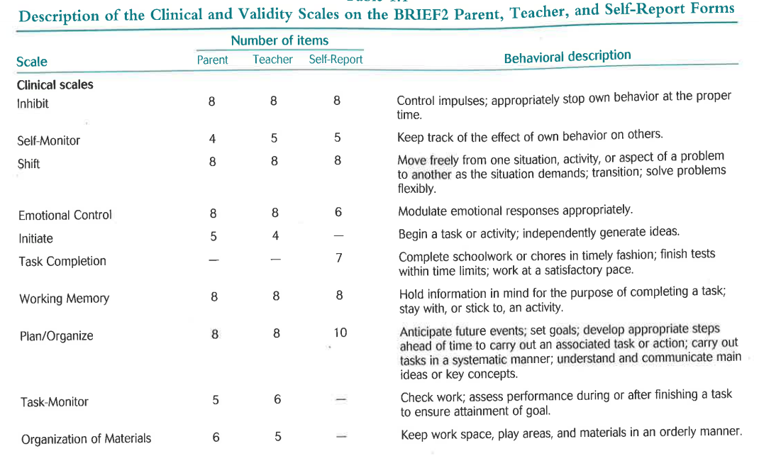
Skills for learning and executive function
Carly completed the self-report version of the Behavioural Rating Inventory of Executive Function (BRIEF). The BRIEF assesses executive function. Executive Function consists of a collection of processes that are important for guiding, directing and managing cognitive, emotional and behavioural functions during problem solving. Carly’s scores on the BRIEF are presented in the table below:

Carly’s BRIEF Scores at age 13 years 9months

Scale/index/  composite | Raw score | T score | *%ile | 90% CI | Verbal Description | Base Rates % | ADHD - C | ADHD - I | ASD
Inhibit | 19 | 75 | 99 | 6 | Clinically Elevated | 4 | 27(TD=0) | 23(TD=9) | 18(TD=0)
Self-Monitor | 12 | 75 | 98 | 7 | Clinically Elevated | 5
BRI | 31 | 77 | 99 | 5 | Clinically Elevated | 4
Shift | 17 | 72 | 98 | 6 | Clinically Elevated | 4
Emotional Control | 13 | 73 | 98 | 7 | Clinically Elevated | 4
ERI | 30 | 75 | 99 | 5 | Clinically Elevated | 5
Task Completion | 18 | 77 | 98 | 6 | Clinically Elevated | 5
Working Memory | 18 | 72 | 97 | 6 | Clinically Elevated | 4
Plan/Organise | 23 | 69 | 94 | 5 | Potentially Clinically Elevated | 9
CRI | 59 | 74 | 97 | 3 | Clinically Elevated | 5
GEC | 120 | 76 | 99 | 3 | Clinically Elevated | 4
Notes:
- T-score :
- Score of 50 is considered average.
- Scores between 60-64 (1 and 1.5 Standard Deviation above the Mean) are considered ‘mildly elevated’
- Scores between 65-69 (1.5 and 2 Standard Deviation above the Mean) are considered ‘potentially clinically elevated’;
- Scores at or above 70 (more than 2 Standard Deviations above the Mean) are considered ‘clinically elevated’.
- * Percentile scores indicate the percentage of children in the standardisation sample with scores at or below that same value.
- ADHD-C = attention deficit/hyperactivity disorder, combined type.
- ADHD-I = attention deficit/hyperactivity disorder, inattentive type.
- TD = typically developing.
- Base Rates refer to the frequency with which scores are seen in the standardisation and clinical samples.

What does scores mean? – Significant regulatory difficulties
- Shift: difficulty in moving freely from one situation, activity, or aspect of a problem to another as circumstances demand. Indicates weaknesses in her ability to make transitions, problem solve flexibly, switch or alternate attention, and change focus from one mind-set or topic to another. Her severe elevated score is reflected in her perseverative behaviours, her tendency to be rigid and inflexible in her reasoning or problem solving skills. This provides a plausible explanation for why Carly if often unable to drop certain topic of interest or move beyond specific disappointment or unmet need.

Carly’s T-score of 71 is significantly more problematic than the average for 11-13 year old girls and puts her in the bottom 1% of other girls that age. A score like hers is likely to be seen in only 4% of typically developing children of the same age and gender as Carly. .

- Task completion: although not a specific executive function per se, it is argued to be a frequent consequence of executive function problems. Difficulties often result from problems in other executive function domains, such as planning, organising, initiating, or sustaining working memory. It is the most frequently elevate scale in children with ADHD and anxiety.

